**Question 1**.  Find the length of an arc in a circle of radius 10 centimeters subtended by the central angle of 50°. Show your work.

**Solution:**

To find the length of an arc in a circle, you can use the formula:

Arc length = $\frac{θ}{360°} 2πr$

Where $θ$ = 50° and r = 10cm

Arc length = $\frac{50}{360} 2π(10)$

Arc length $≈2.7778(20π)$

Arc length $≈55.5556π$

Arc length $≈55.5556(3.14159)$

**Arc length $≈174.999cm$**

Therefore, the length of the arc is approximately **174.999 centimeters.**

**Question 2**.  Graph [ f(x)=x\ sin\ x ](https://my.uopeople.edu/filter/tex/displaytex.php?texexp=%20f(x)%3Dx\%20sin\%20x%20) on [-4π, 4π] and verbalize how the graph varies from the graphs of [ f(x)= \pm x  ](https://my.uopeople.edu/filter/tex/displaytex.php?texexp=%20f(x)%3D%20\pm%20x%20%20).

Graph [ f(x)= \frac{sin\ x}{x}  ](https://my.uopeople.edu/filter/tex/displaytex.php?texexp=%20f(x)%3D%20\frac%7bsin\%20x%7d%7bx%7d%20%20)  on the window [−5π, 5π] and describe freely what the graph shows. You can use [www.desmos.com/calculator](http://www.desmos.com/calculator) to obtain the graphs.

**Solution:**

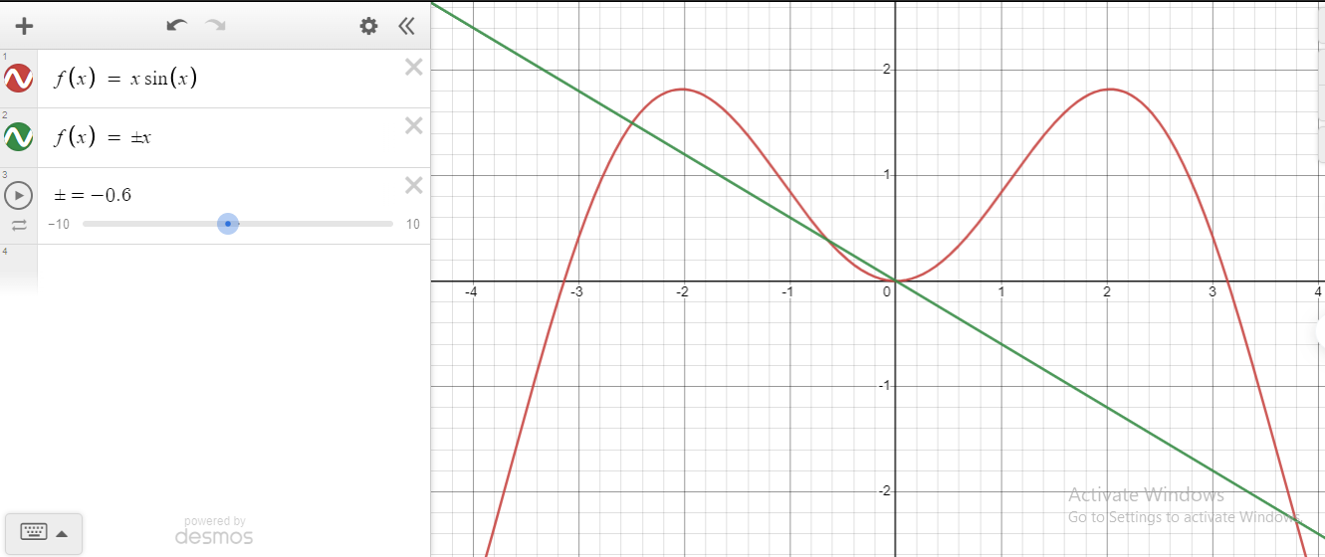

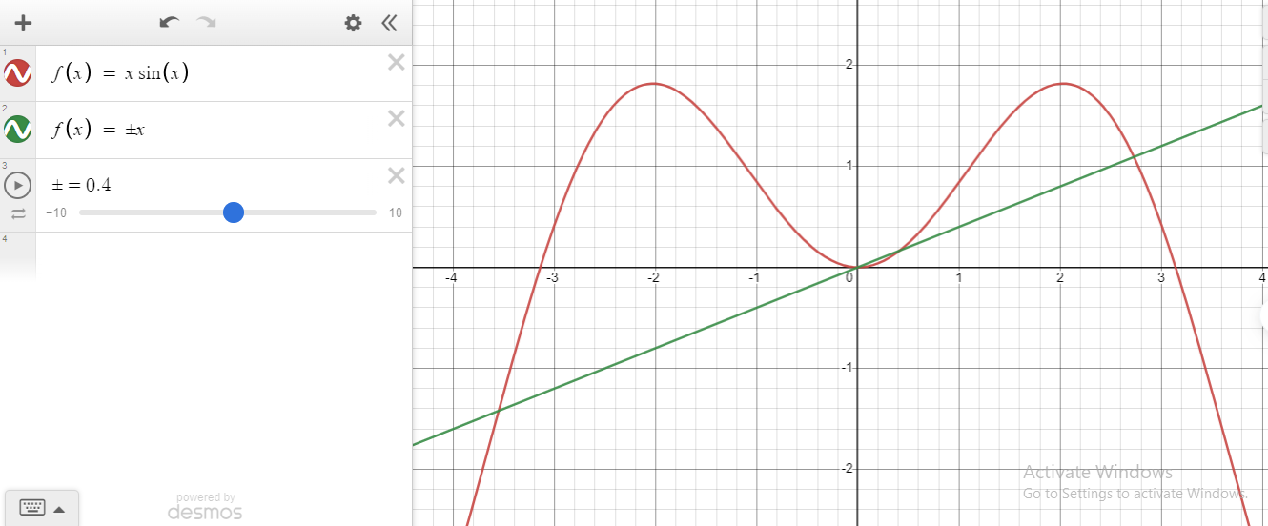

**Comparison with *f*(*x*) = ±*x*:**

1. **Amplitude Variation**: Unlike the constant amplitude in the linear functions *f*(*x*)=±*x*, the graph of *f*(*x*) = *x* sin(*x*) shows a variable amplitude. The amplitude is modulated by the *x* values, resulting in a more dynamic and oscillatory pattern.
2. **Oscillatory Behavior**: The presence of the sine function introduces oscillations, creating a wavy pattern in *f*(*x*) = *x* sin(*x*). This contrasts with the straight-line behavior of *f*(*x*)=±*x*. The oscillations become more pronounced as *x* values increase or decrease, providing a visually distinct and intricate graph.
3. **Complex Interplay**: The graph of *f*(*x*) = *x* sin(*x*) exhibits a complex interplay between the linear term (*x*) and the sinusoidal term (sin(*x*)). This interplay results in a visually captivating pattern, showcasing the synergy of a linear trend and sinusoidal oscillations.

**Part 02**

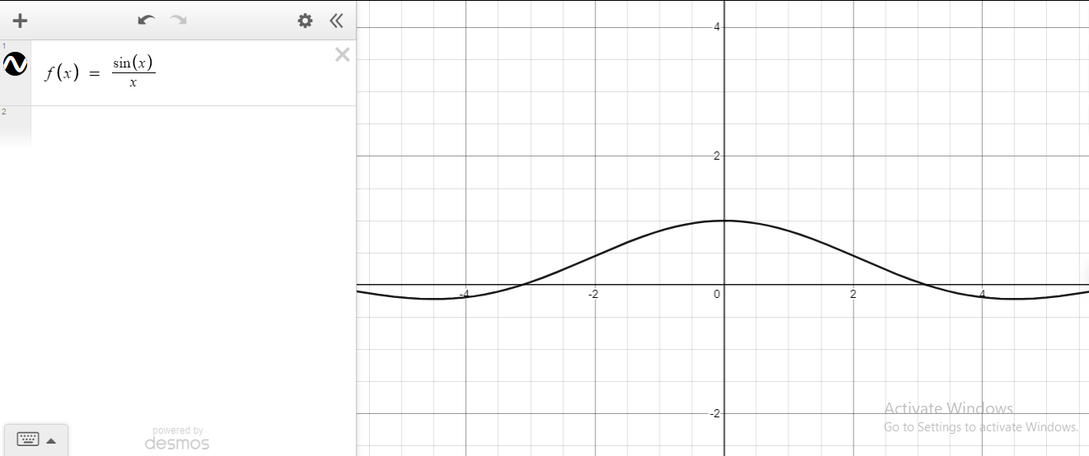

1. **Removable Discontinuity at *x* = 0:**
   * The graph shows a prominent gap or hole at x = 0, indicating a removable discontinuity. This occurs because the function is undefined at *x* = 0 due to division by zero.
2. **Oscillatory Behavior:**
   * Away from *x* = 0, the graph exhibits oscillations. The sine function in the numerator contributes to periodic variations as *x* moves away from zero.
3. **Decay as ∣*x*∣ Increases:**
   * As ∣*x*∣ increases, the amplitude of the oscillations decreases, and the function tends to approach zero. The 1/*x* term in the denominator causes the amplitude to diminish, leading to a damping effect.
4. **Symmetry:**
   * The function is symmetric with respect to the y-axis (*y*-axis). This symmetry arises from the even symmetry of the sine function.
5. **Asymptotic Behavior:**
   * The graph approaches zero as ∣*x*∣ becomes very large, demonstrating asymptotic behavior. This is a consequence of the 1/*x* term, which dominates for large values of ∣*x*∣.

**Question 3**. A 23-ft ladder leans against a building so that the angle between the ground and the ladder is 80°. How high does the ladder reach up the side of the building? Show the steps of your reasoning.

**Solution:**

**Given information:**

Angle between the ground and the ladder (*θ*) = 80°

Length of the ladder (hypotenuse) = 23 ft

1. **Identify the Trigonometric Relationship:** The problem involves a right-angled triangle, where the ladder forms the hypotenuse, and the height along the building is the opposite side. The relevant trigonometric relationship for this scenario is the sine function:

Sin($θ$) = $\frac{perpendicular}{hypotenuse}$

Where $θ$ = 80 $°$

Hypotenuse (ℎ) = 23 ft (length of the ladder)

1. **Substitute Known Values and Isolate the Variable:** Substitute the given values into the sine function equation and solve for the height by isolating the variable on one side of the equation:

height = 23 sin (80 $°$)

1. **Calculate the Height:** Use a calculator to find the sine of 80 degrees and then multiply it by 23:

height $≈$ 23×0.9848

**height $≈$ 22.65ft**

So, the ladder reaches approximately **22.65 feet** up the side of the building.

**The End**